*Solution for Assignment 3:*

COMP-352

by

Shadi Jiha (40131284)

Concordia University

Department of Computer Science and Software engineering

18 June 2021

**Question 1:**

1. Content of the array of 13 elements (each index represents a linked list):

[[65], [105], [28, 223], [185, 120], [225, 69], [70, 122, 18, 44], null, [85, 111, 59], [177], [256], [10, 49, 140], [245, 180], [12]]

1. 11 collisions

**Question 2:**

1. [19, 58, null, null, 62, 24, null, null, null, 28, null, 36, null, 47, null, null, null, 17, 37]
2. 3
3. 6 total collisions
4. $\frac{9 entries}{19 size}=0.47$ is the load factor

**Question 3:**

1. [null, 36, 58, null, null, null, null, null, null, 47, null, null, null, null, null, null, null, 17, 37]
2. 2. $O(n)$
3. 3 collisions

**Question 4:**

1. 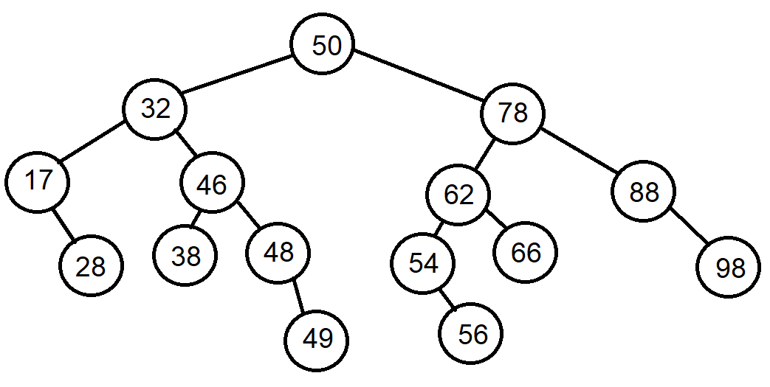After inserting 56
2. After removing 28 to the initial tree

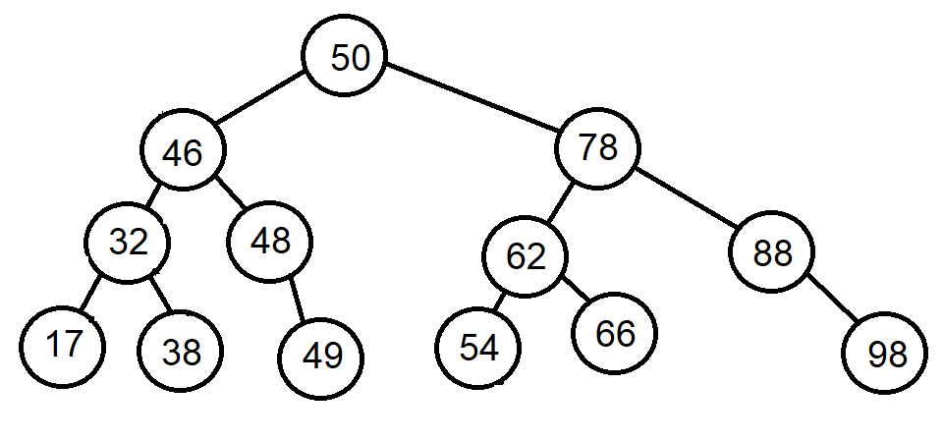

**Question 5:**

1. <https://www.chegg.com/homework-help/questions-and-answers/question-5-consider-following-elements-12-47-74-19-89-4-63-26-53-8-93-71-15-87-50-17-82-tr-q79627180>
2. Da
3. Fa

**Question 6:**

1. Matrix representation (empty squares are 0):

|  |  |  |  |  |  |  |  |  |  |  |
| --- | --- | --- | --- | --- | --- | --- | --- | --- | --- | --- |
|  | 0 | 1 | 2 | 3 | 4 | 5 | 6 | 7 | 8 | 9 |
| 0 |  |  |  |  |  |  | 1 |  |  | 1 |
| 1 |  |  | 1 |  |  |  |  | 1 |  |  |
| 2 |  | 1 |  | 1 | 1 | 1 |  | 1 | 1 |  |
| 3 |  |  | 1 |  |  | 1 |  |  |  |  |
| 4 |  |  | 1 |  |  | 1 | 1 |  |  |  |
| 5 |  |  | 1 | 1 | 1 |  | 1 |  |  |  |
| 6 | 1 |  |  |  | 1 | 1 |  |  | 1 | 1 |
| 7 |  | 1 | 1 |  |  |  |  |  | 1 |  |
| 8 |  |  | 1 |  |  |  | 1 | 1 |  | 1 |
| 9 | 1 |  |  |  |  |  | 1 |  | 1 |  |

1. List representation (with linkedlist):

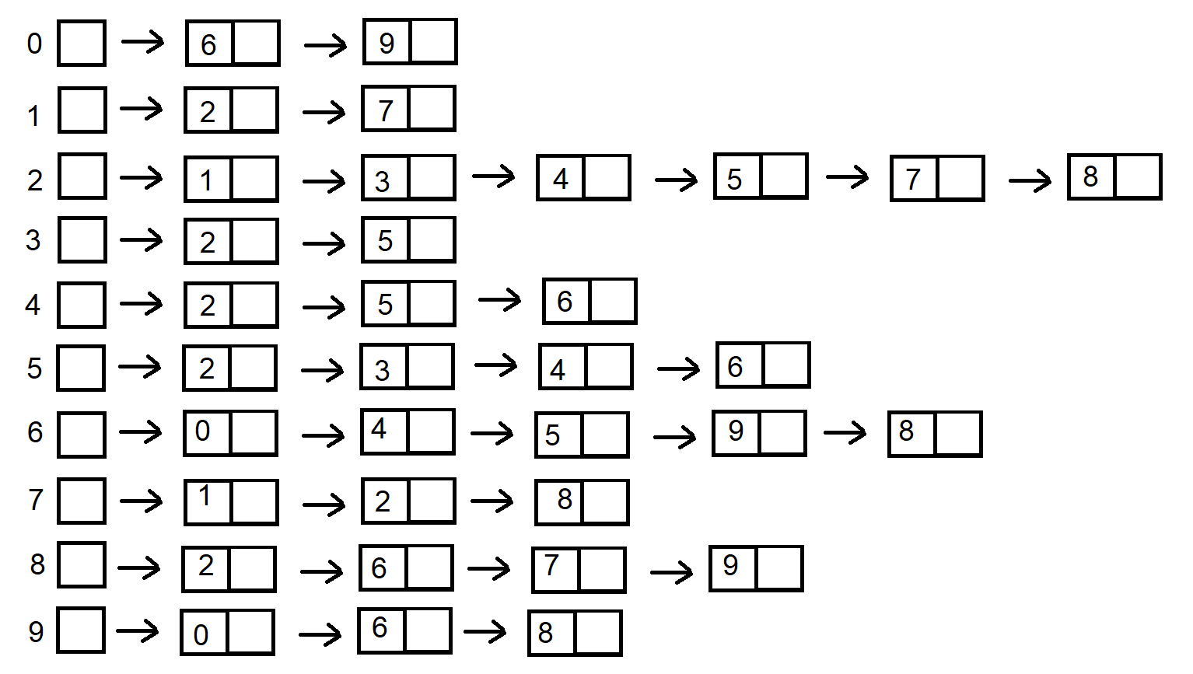

1. Using breadth-first tree starting at 0:

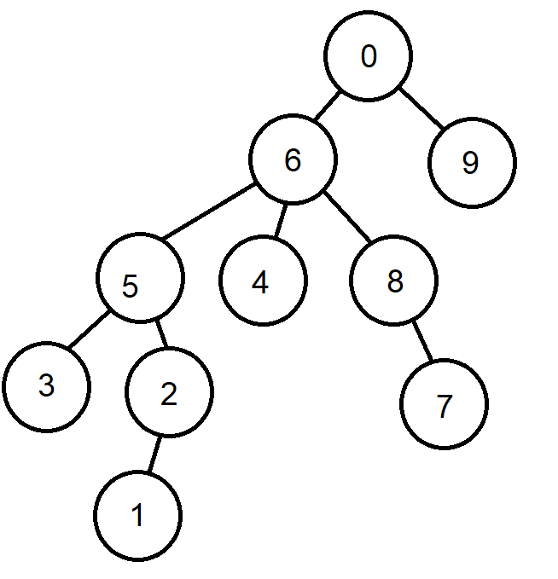

1. Using depth-first search tree (also starting at 0):

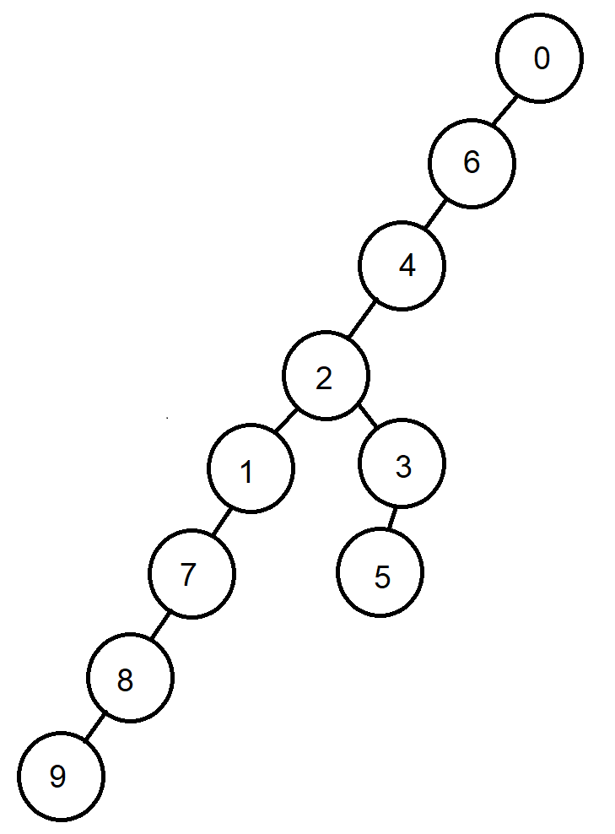

**Question 7:**

In order to get these answers I have implemented the Dijkstra’s Algorithm’s pseudo code in java and ran it on the provided graph

|  |  |  |
| --- | --- | --- |
| Source | Destination | Distance |
| H | A | 2 |
| H | G | 2 |
| H | I | 1 |
| H | B | 8 |
| H | F | 3 |
| H | E | 6 |
| H | J | 3 |
| H | D | 6 |
| H | C | 11 |